**Predicting the Spread of Asian Carp in the Mississippi River Basin Using GIS**

Notice: Dr. Bryan Runck

Author: Erik Sauer

Date: December 21, 2022

**Project Repository:** [Link](https://github.com/esauer2/GIS-5571---Final-Project)

**Abstract**

Estimating the populations of invasive species informs models for their distribution which can then be used in management decisions. The risks to ecosystem services and ecology can be mitigated based on these predictions. This project aims to develop a model for estimating the distribution of Asian (Bighead, Black, Silver, and Grass) carp species in the Mississippi River Basin using data accessed with an ETL methodology. The workflow for this process will use arcpy in an ArcGIS Pro Notebook to streamline data retrieval and processing. The assessment will use precipitation, salinity, and water feature information to create a presence-only prediction. The basis for the prediction will be carp point data from 2011 to 2018 in the study area (see Figure 1) sourced from the USGS.

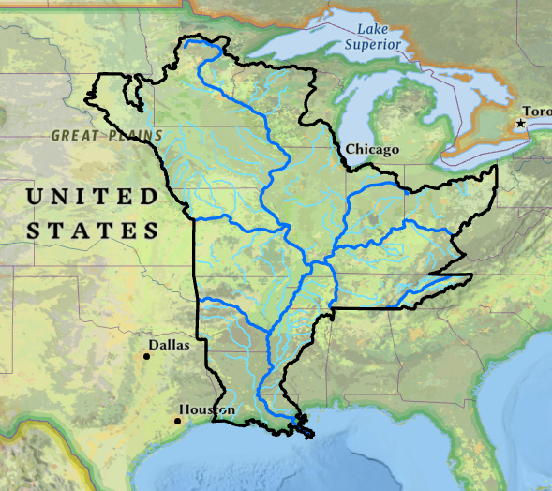

*Figure 1. Study Area extent including river features*

**Introduction**

The rapid spread of invasive carp species in waterways throughout the Midwest has caused millions of dollars’ worth of damage to fisheries and other ecosystem services provided by native species (Chick et al. 2020). Four species of invasive carp are present in the Midwest: Silver, Grass, Bighead, and Black carp. These species can outcompete native populations of fish through their larger size, rapid rate of reproduction, and aggressiveness. As shown in Figure 2, there are established populations of carp throughout the Mississippi and the central Midwest. There is a significant threat that carp will spread to the Great Lakes and damage the lucrative fishing industry present there (Chick et al. 2020). The USGS has begun tracking the spread of fish species in rivers and lakes using telemetry in order to better understand the distribution and behavior of these species. GIS modeling is the best way to understand the nature of the risk presented by this invasive spread (USGS Asian Carp Integrated Control and Containment). This project seeks to model distribution of invasive Asian carp species using collected fish telemetry data provided by the USGS in the Mississippi River Basin.

*Figure 2. Distribution of Carp Species as of April 2014*

An interagency project called the Great Lakes and Interbasin Mississippi River Study (GLMRIS) has worked to assess the state of aquatic nuisance species in the area and potential solutions to stop their spread (GLMRIS 2014). Both Silver and Grass carp are considered nuisance species in the Mississippi River Basin, and the primary proposed strategies are structural improvements such as physical or electrical barriers along waterways, separation of hydrologic regions, and mechanical removal (GLMRIS 2014). A prediction of updated carp distribution would help in selection of potential barrier sites and help identify the most at-risk areas.

Studies aiming to model the distribution of carp species in the Great Lakes area have used the environmental niche model to estimate geographic spread (Wittman et al 2017). As in the presence-only prediction tool, these tools use the combination of known species locations with relevant environmental data to form predictions (Wittman et al 2017). The Great Lakes study incorporated an environmental climate variable raster that included precipitation, temperature and seasonality data to form a prediction.

*Table 1. Project requirements for the prediction approach*

|  |  |  |  |  |  |  |
| --- | --- | --- | --- | --- | --- | --- |
| **#** | **Requirement** | **Defined As** | **(Spatial) Data** | **Attribute Data** | **Dataset** | **Preparation** |
| 1 | Access fish and explanatory data, pull from web | Use requests, csv, and zipfile modules to retrieve and store data | Point locations, polygons,  raster | Carp species and count, precipitation, feature type | [Esri Source](https://services6.arcgis.com/Sjtjj6zwMH9eAgbl/arcgis/rest/services/All_invasive_carp_Data/FeatureServer)  [Natural Earth](https://www.naturalearthdata.com/http/www.naturalearthdata.com/download/10m/physical/ne_10m_rivers_lake_centerlines.zip)  [NRCS](https://www.nrcs.usda.gov/sites/default/files/2022-06/Mississippi_River_Basin_CCA.zip)  PRISM  [PANGEA](https://hs.pangaea.de/bio/Salinity_database/Thorslund-vanVliet_2020/Rivers_database.csv) | Locate access urls with web inspector |
| 2 | Data Preparation | Add layers to the map and create points from tables | Point locations, polygons,  raster | Carp species and count, precipitation, feature type | “” | Unzip data from workspace |
| 3 | Data Processing | Clip/Mask data, interpolate salinity data | Point locations, polygons,  raster | Feature extent, XY location | “” | Add data to map and set workspace |
| 4 | Convert water features to raster | Use polyline to raster tool to generate extent for prediction | Polygons | Feature type | [Natural Earth](https://www.naturalearthdata.com/http/www.naturalearthdata.com/download/10m/physical/ne_10m_rivers_lake_centerlines.zip) | Clip features |
| 5 | Predict Invasive Spread | Use point location and explanatory rasters to generate presence-only prediction | Raster layer, points | Raster value, point location | [Esri Source](https://services6.arcgis.com/Sjtjj6zwMH9eAgbl/arcgis/rest/services/All_invasive_carp_Data/FeatureServer)  [Natural Earth](https://www.naturalearthdata.com/http/www.naturalearthdata.com/download/10m/physical/ne_10m_rivers_lake_centerlines.zip)  [NRCS](https://www.nrcs.usda.gov/sites/default/files/2022-06/Mississippi_River_Basin_CCA.zip)  PRISM  [PANGEA](https://hs.pangaea.de/bio/Salinity_database/Thorslund-vanVliet_2020/Rivers_database.csv) | Prepare explanatory rasters |

**Input Data**

This project will rely on USGS historical fish data acquired from 2011-2018 to create a point layer to be use in the presence-only prediction. The USGS data includes all reported instances of nonnative species across the United States as they are reported, so the data will be processed as an ArcGIS Online layer to extract only the Asian carp species. The river and lake features are shapefiles of major water features sourced from the Natural Earth site in North America. After clipping, the shapefiles will be converted a generalized raster and used as an explanatory raster in the final prediction. This raster will also represent the extent of the water features where carp presence will be estimated.

Using a shapefile from the NRCS, the Mississippi River Basin Boundary will form the extent of the study area for clipping and masking. The PANGEA project keeps global salinity data from 1986 to 2022 in tabular format. After accessing the full CSV, this data will need OIDs and querying before analysis. Direct links to the source data are available in Table 2, as well as the original data owner.

*Table 2. Planned sources of invasive carp distribution data*

|  |  |  |  |
| --- | --- | --- | --- |
| **#** | **Title** | **Purpose in Analysis** | **Link to Source** |
| 1 | USGS Asian Carp Species Data | Point locations to use as inputs for Prescence-only prediction | [Esri Source](https://services6.arcgis.com/Sjtjj6zwMH9eAgbl/arcgis/rest/services/All_invasive_carp_Data/FeatureServer) |
| 2 | River Features | Use for shapefile information and feature type raster in analysis | [Natural Earth](https://www.naturalearthdata.com/http/www.naturalearthdata.com/download/10m/physical/ne_10m_rivers_lake_centerlines.zip) |
| 3 | Mississippi River Basin Boundary | Form study extent to clip features and extract by mask | [NRCS](https://www.nrcs.usda.gov/sites/default/files/2022-06/Mississippi_River_Basin_CCA.zip) |
| 4 | Annual Precipitation Raster | Explanatory Raster in prediction | PRISM |
| 5 | Salinity Point Data | Interpolated as an Explanatory Raster in prediction | [PANGEA](https://hs.pangaea.de/bio/Salinity_database/Thorslund-vanVliet_2020/Rivers_database.csv) |
| 6 | Lake Features | Use for shapefile information and feature type raster in analysis | [Natural Earth](https://www.naturalearthdata.com/http/www.naturalearthdata.com/download/10m/physical/ne_10m_lakes.zip) |

**Methods**

Initially, this project focused on accessing data from five different online data repositories. The point locations for Asian carp were retrieved as a point layer on ArcGIS Online from a larger shapefile of all fish species. This data was added manually in ArcGIS Pro to the analysis map and was referenced using the layer name in later analysis. For the rest of the data, access urls retrieved using web inspector, the requests module will all accessing and writing the content to files. The salinity and water features data required headers to determine there was a user accessing the data. With the OS module, a new folder was created to act as the working directory and to store the data zipfiles and CSVs. The data was then stored using the csv and zipfile modules.

The salinity csv data included global historical data for nearly forty years and needed to be processed before use in the analysis. The first step in this process was to use the “copy rows” tool to generate OIDs for each sample location (see Figure 3). Once this was complete, the “table to table” tool allowed querying in the new table. The query was set up as follows: County is equal to USA, date is on or after 1/1/2018, and date is on or before 6/1/2018. This reduced the number of redundancies in the data as well as make the table small enough to apply the “convert XY Table to Points” process for the remaining 84,000 observations.

With all data added to the map, each shapefile was clipped to the Mississippi River Basin boundary. The precipitation raster was masked using “extract by mask”. The salinity data points were interpolated with Kriging using the ordinary method and the spherical semi-variogram model. The output cell size was set to .07. The rivers shapefile was then converted to raster using “polyline to raster” with scale ranks as the value field, output cell size of .1, and maximum length as the cell assignment type.

*Table 3. Input Features used in the prediction analysis*

The “Presence-Only Prediction (Max-Ent)” tool was used with the Asian carp point data as the input point features. The interpolated salinity raster, precipitation raster, and river raster served as the explanatory training rasters. The explanatory variable expansion was the squared (quadratic) version and the study area was determined using the convex hull method. Without input background points, the tool generated these points as a part of the analysis process as can be seen in Table 3. The output of the prediction was specified as a raster layer.

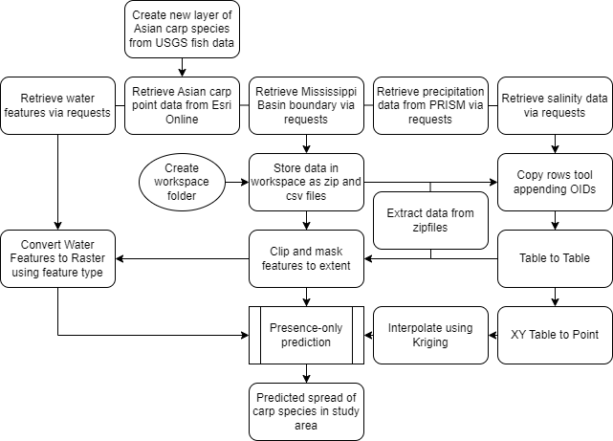

*Figure 3. Data Flow Diagram to Perform Presence-only Prediction*

**Results**

The prediction tool output a raster that matched the extent of the smallest raster. In the case of this analysis, the output followed the extent of the entire Mississippi River Basin. This output was masked to the extent of the river and lake features to show the presence prediction for only the water areas. The masked result is shown in Figure 4, with the higher probability areas falling to the Northwest of the study area. This likely indicates the impact of the interpolated salinity data on the probability of presence in the coastal, higher salinity areas.

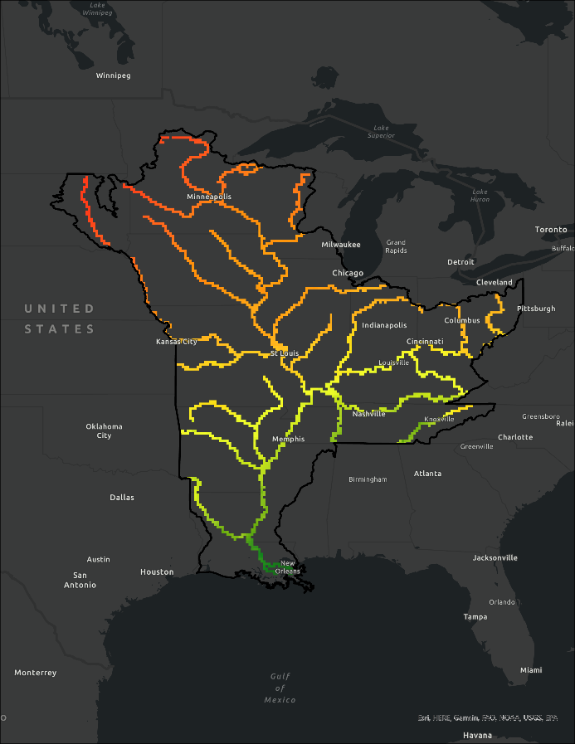

*Figure 4. Prediction output raster surface in water features (higher probability values shown in red, lower in green)*

The graph shown in Figure 5 shows the correctly classified presence at an estimated 82%, with 18% incorrectly classified in the input data. The generated background points indicate 58% are predicted to include carp populations. The presence success rate is likely inaccurate, as the input data would not have such a high level of misclassification.

*Figure 5. Estimate success rate of prediction and potential presence.*

**References**

*Asian Carp Integrated Control and Containment | U.S. Geological Survey*. https://www.usgs.gov/special-topics/great-lakes-restoration-initiative/science/asian-carp-integrated-control-and. Accessed 9 Oct. 2022.

Chick, John H., Daniel K. Gibson-Reinemer, Lori Soeken-Gittinger, and Andrew F. Casper. “Invasive Silver Carp Is Empirically Linked to Declines of Native Sport Fish in the Upper Mississippi River System.” *Biological Invasions* 22, no. 2 (February 1, 2020): 723–34. <https://doi.org/10.1007/s10530-019-02124-4>.

*Database and Web Application for Invasive Carp Telemetry Data (FishTracks) | U.S. Geological Survey*. https://www.usgs.gov/centers/upper-midwest-environmental-sciences-center/science/database-and-web-application-invasive. Accessed 3 Nov. 2022.

*GLMRIS Report*. <https://glmris.anl.gov/glmris-report/>, 2014. Accessed 9 Nov. 2022.

Wittmann, Marion E., et al. “Refining Species Distribution Model Outputs Using Landscape-Scale Habitat Data: Forecasting Grass Carp and Hydrilla Establishment in the Great Lakes Region.” *Journal of Great Lakes Research*, vol. 43, no. 2, Apr. 2017, pp. 298–307. *ScienceDirect*, https://doi.org/10.1016/j.jglr.2016.09.008.

***Figure 2 Image Source:***

[*http://invasivecarp.us/Documents/ACDistribution.pdf*](http://invasivecarp.us/Documents/ACDistribution.pdf)